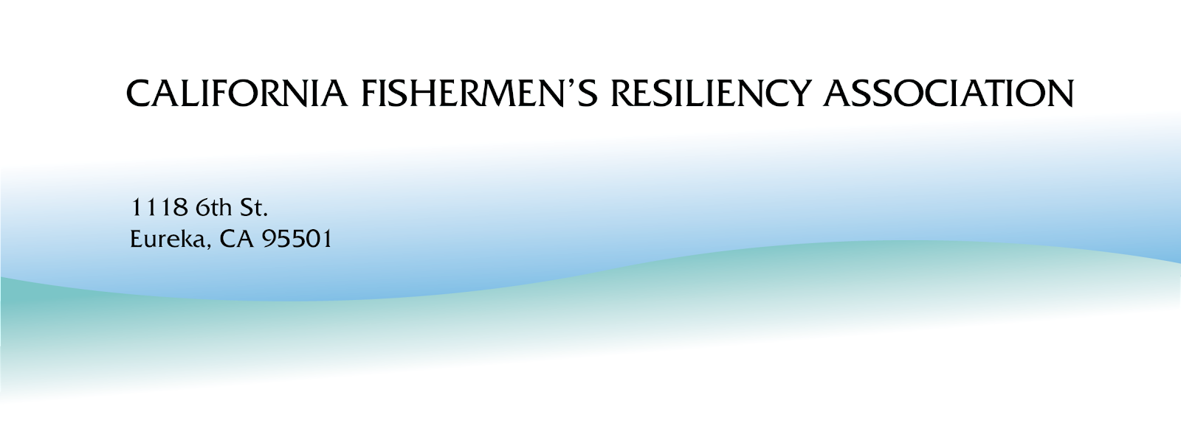
CFRA Board Report #32
October 1 - December 31
https://www.californiafishermensresiliencyassociation.com

Summary/Current Context

The Coastal Commission 7C Statewide Strategy committee process is nearly complete with one more meeting of the committee scheduled for January 13, 2026.

Since the initial meetings of the 7C working group, Coastal Commission staff have changed their position on industry-to-industry agreements between OSW developers and fishermen’s associations (CFRA included). For many fishermen, the core impetus for this 7c process was the possibility of creating a comprehensive, enforceable, mutually beneficial agreement between a fishing community/association and an offshore wind power developer. The hopes and expectations of the fishing industry were such that a bi-lateral industry to industry agreement, modeled on the California cable committees, would provide fishing communities equal standing in implementing the idea of co-existence on California’s community fishing grounds.

This is not going to happen.

Likewise, the fishing industry no longer has a seat at the mitigation negotiation table, nor is there a clear path for mitigation fund administration by one or two broad-based, democratically governed fishermen’s legal entities. Instead, these roles have been deferred to an undefined “selection” process at some point in the distant future.

At the request of various state agency staff, the CFRA was incorporated to fulfill these purposes, and the Ocean Protection Council (OPC) provided funding for CFRA to promote cooperation with offshore wind developers through industry-to-industry agreements. However, due to changes that occurred in the 7(c) process, the CFRA Board of Directors and its sixteen member fishing associations have begun discussions about the future of this young nonprofit organization.

On November 18, the CFRA held a Board of Director’s meeting inviting all of the CFRA member associations to attend. The purpose of this meeting was to begin a discussion as to the fate of the CFRA in light of the changes in the Coastal Commission 7C Statewide Strategy process. These changes question the relevancy of this organization. CFRA staff presented three possible options for the future of this organization: hibernation until some future date, complete repurposing, and finally, dissolution. (Link to Operations Manual Section)

Activities supporting Phase 1 of the OPC grant
October -
- October 6 - Subgroup 5 - overview of Socio-economic impact consideration
- October 9 - Subgroup 6 - Discussion of Resiliency funds management and organization
- October 15 - Subgroup 2 - Template Agreements - discussion of the change in position by the Coastal Commission
- October 15 - Subgroup 6 - Discussion of the Introductory Chapter
- October 16 - Subgroup 5 - edits to the Northern Economics Report
- October 27 - Meeting with 7C fishermen - preparation for upcoming in-person 7C meeting in Sacramento.
- October 30 - Subgroup 6 - organization and management of Compensatory Mitigation

November

- November 4-5 - 7C meeting #8 was held in-person at Sacramento State University
- November 6 - a report was submitted by CFRA staff to our grant manager and accountant requesting honoraria and travel reimbursements for qualified fishermen, fisheries representatives and tribal representatives that attended 7c meeting #8
- November 10 - honoraria and travel reimbursement checks issued to qualified 7c participants.
- November 19 - honoraria requested for fishermen that attended the 11/18/25 CFRA Board meeting. $100 was paid to each of 7 qualified fishermen.
- November 17 - Check-in meeting with Amy Vierra (a 7c participant) thanking the SLC for their support .
- November 29 - Meeting with a few 7c fishery reps to follow up on 7c meeting #8

December
- December 6 - Review and edit 7C’s Transmittal Letter (this included several emails and calls to get feedback from 7c fishermen)
- December 12 - Submission of comment/edits to Transmittal Letter

Activities support Phase 2 of the CFRA’s OPC Grant

October
- October 1 - CFRA Staff Meeting
- October 1 - Meeting with Santa Barbara Fishermen’s Association to talk about the possibility of authoring a white paper concerning impacts to port infrastructure from Ocean Industrialization and wind power.
- October 2 - Meeting with City of Eureka Economic Development and Planning Commission Staff to talk about waterfront land usage and zoning for upcoming wind power development in order to request a draft policy document for the “Eureka Project”
- October 6 - Release of CFRA Newsletter
- October 6 - Discussion with Melissa Mahoney of Monterey Bay Fisheries Trust about the CFRA’s work on minimizing impacts to fishermen from OSW and our support and funding from OPC
- October 6 – Participated in CalJobs First Blue Economy Partner meeting
- October 14 - CFRA Board Report #31 covering July-Sept. sent out to CFRA contact list
- October 15 - CEC meeting via zoom re: port development
- CFRA Staff meeting
- October 15 - Submission of two OPC quarterly reports: C0210410 and C0210414
- October 15 - Follow-up interview with Marcos Caballero of CBS. He was looking for the CFRA perspective on marketing fish with a focus on fish markets in California
- October 21 - Receipt of Quarterly Reports from OPC
- October 22 - CFRA Staff meeting
- October 22 - Call with Tanner Etherton of California Sea Grant. He invited Ken to serve as a panelist at the “State of the Coast” (to be held in Coos Bay) sponsored by Sea Grant Oregon to discuss the CFRA white paper on the proposed Heavy Lift Terminal in Humboldt Bay.
- October 27 - Interview with Patricio O’Donoghue, a reporter at the Richmond Confidential working on a story about a $750,000 grant that was awarded to Richmond by the California Energy Commission for a feasibility study to determine if the city's port can host offshore wind infrastructure. He reached out to the CFRA thinking that our perspective would be valuable for their readers.
- October 31 - CFRA Staff meeting

November

- November 10 - CFRA Staff Meeting
- November 10 – Attended Eureka Planning Commission meeting to participate in discussions and recommendations for supporting the local commercial fishing fleet
- November 13 - Ken Bates participated as a panelist representing the CFRA for the CEC’s AB3 webinar concerning port readiness.
- November 14-15 - Ken Bates participated as a panelist at Oregon’s Sea Grant “State of the Coast” conference
- November 18 - CFRA Board Meeting - This meeting included member representatives from 16 port associations.
- November 19 - CFRA Staff Meeting
- November 29 – Published paper Economic Effects of Climate Shift and California Climate Policy on Fishermen (https://www.californiafishermensresiliencyassociation.com/_files/ugd/1298ad_90b19e2afef84467b7e9edd45704ca1a.pdf)

December
- December 3 - CFRA Staff Meeting
- December 3 - Minutes of November 18th CFRA Board Meeting approved
- December 4 - Renewed CFRA’s Directors and Officers Liability Insurance

Thank you for taking the time to read this report. We always appreciate the feedback that we have gotten from you.

Ken Bates, Linda Hildebrand and Michael Kraft
California Fishermen’s Resiliency Association

