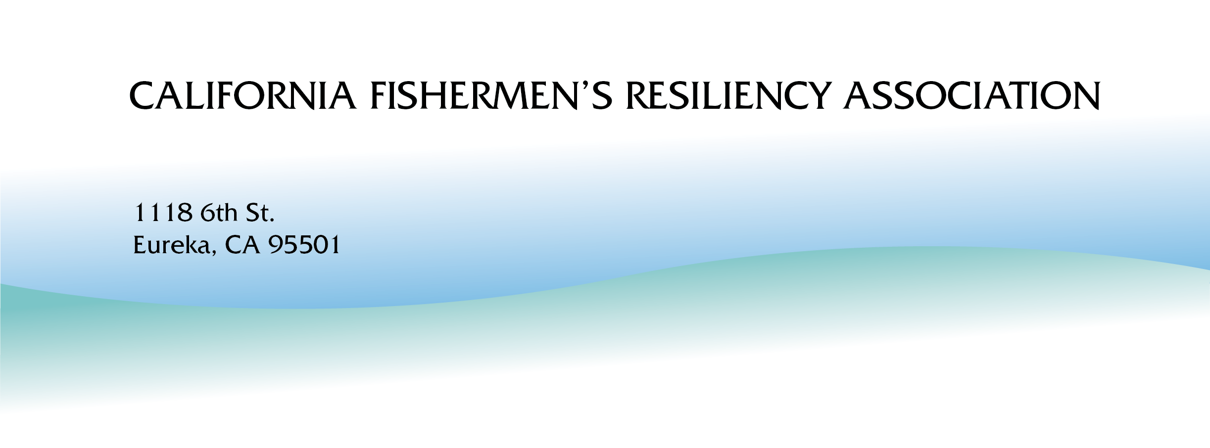

CFRA Board Report #34
April 1, 2026- July 31, 2026
https://www.californiafishermensresiliencyassociation.com
Summary/Current Context
During the second quarter of 2026, the California Fishermen’s Resiliency Association (CFRA) advanced project activities through ongoing coordination, reporting, and engagement with key partners. CFRA maintained regular staff meetings, completed required reporting to the Ocean Protection Council (OPC), and continued financial administration activities.
While not an aspect of this agreement, the CFRA closed out its previous grant in the first two quarters of this year. (Funding ended toward the end of Q1, with reporting and wrap-up activities continuing into Q2).Key efforts this quarter included significant work and planning for a major pivot in the utilization of funding of this contract, resulting in a draft contract amendment currently working its way through OPC processes. Originally, this agreement was envisioned to cover extensive negotiations between California commercial fishing interests and offshore wind developers. As the process mandated by SB 286 (Maguire) concluded, it became clear that these negotiations and associated costs would not be happening. While regrettable to the fishing community, this allowed the OPC and CFRA to move forward on a piece of unfinished business, to provide a case study and proof of concept for a socioeconomic impact methodology for fisheries affected by offshore wind development in California. CFRA also engaged with external partners, including the Alliance of Communities for Sustainable Fisheries and Northern Economics Inc. to discuss the possibility of funding a trial run of the Northern Economics mitigation model as suggested by OPC staff.
The CFRA participated in the Humboldt Bay Shellfish Growers Meeting, where CFRA’s prior work on assessing impacts to Humboldt Bay from heavy lift terminal development was recognized.
Deliverables progressed with the completion and distribution of CFRA Board Report #33, submission of required quarterly reporting, and continued development of white papers focused on coastal ports and fishing infrastructure. The CFRA membership and staff continue to discuss the relevance of the CFRA organization in light of the directional changes taken by the Coastal Commission’s 7C process concerning the Statewide Strategy.
Overall, the project remains on schedule, with continued progress anticipated in reporting, stakeholder engagement, and development of technical and policy-related materials in the coming quarter.
For the first time in three years, California reopened its commercial salmon season, creating a rare opportunity for fishermen to earn income after an extended closure. Many of the fishermen involved in the CFRA have been on the water since late April and are expected to continue fishing until the harvest quota is reached, which could occur as late as August. As a result, their availability to participate in meetings and other aspects of the CFRA process has been significantly reduced during the fishing season.
April, May June, July 2026
April
- April 1 - Staff Mtg w/ Michael Kraft, grant manager
- April 1 - CFRA bank statements sent to grant manager and accountant.
- April 1 - CFRA Board Meeting w/Board of Directors and Consulting members
- April 2 - Request for CFRA honoraria sent
- April 8 - Staff Mtg w/Michael Kraft
- April 8 - Mtg w/PCFFA
- April 8 - Submitted Quarterly Reports for Phase 1 and 2
- April 9 – Meeting/water tour with Eureka City Staff of Humboldt Bay areas that would be affected by wind and heavy lift terminal development
- April 15 - Staff Mtg w/Michael Kraft - discussion of website updates
- April 16 - Coastal Commission Meeting - Approval and Adoption of Statewide Strategy
- April 27- Board Report sent out
- April 29 - Mtg w/PCFFA
- April 29- Sent Fund redirection letter to OPC (link?)
- April 30 - CFRA release of Newsletter
May
- May 1 - Submitted CFRA Bank Statements
- May 15 - Request to meet sent via email from the California Wetfish Producers Association, to converse about artisanal level small-scale squid fishing
- May 21 - Meeting with Northern Economics, OPC and Coastal Commission Exploratory discussion about funding a Northern Economics Hypothetical Case Study (trial run) of the methodology contained within the Statewide Strategy with remaining CFRA funds.
- May 22 – Michael Kraft call with Melissa Errend, Northern Economics, re: socioeconomic impact methodology/case study
- May 31 – CFRA staff call (KB and LH salmon fishing)
June
- June 1 - Submitted CFRA Bank Statements
- June 24 - CFRA Staff Mtg w/ Michael Kraft
- June 24 - Mtg w/ Rikki Erickson - Presentation and discussion of Fishing Community OSW Framework
- June 25 - Mtg w/oyster farmers at the Farm Bureau - concerns from impacts of Heavy Lift Terminal project proposed for Humboldt Bay on existing aquaculture activities
- June 26 - Conversation with Peter Halmay about Market Squid EFP
- June 30 - Conversation with John Ugoretz and Brianna Brady about consideration of the CFRA sponsoring a Market Squid EFP
July
- July 1 - CFRA Staff mtg w/ Michael Kraft
- July 1 - Submitted CFRA bank statements to grant manager and accountant
- July 9 - Submitted CFRA-OPC Quarterly Report #15 - P2- 4-1-26 -6-30-26 CFRA-OPC
- July 13 - CFRA Staff mtg w/ Michael Kraft
- July 13- Release of CFRA Newsletter
- July 15 - Review Northern Economics contract w/ Dustin Owens (CFRA Attorney)
- July 17 - Call with Mark Fina about Market Squid EFP
- July 17 - Check-in call with Amy Vierra of State Lands
- July 27 - CFRA Board Meeting CFRA Board Meeting Minutes

Thank you for taking the time to read this report. We always appreciate the feedback that we have gotten from you.
Ken Bates, Linda Hildebrand and Michael Kraft
California Fishermen’s Resiliency Association

